Go to tradingview.com and click on Sign In

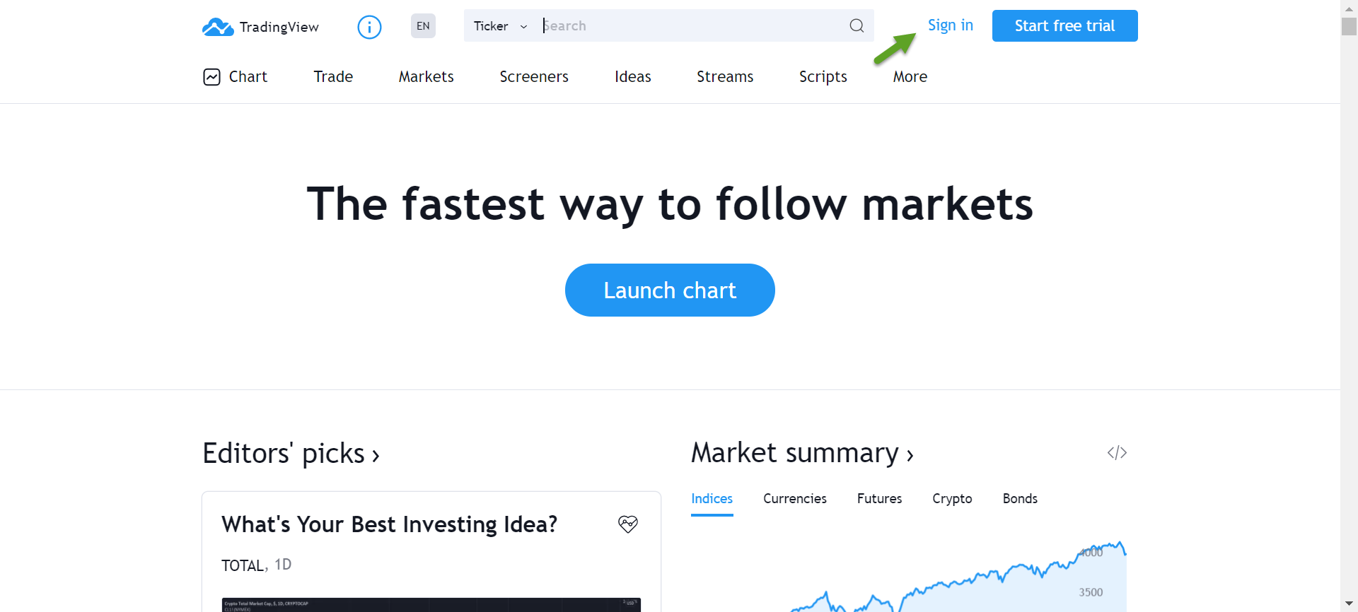

Click Google icon

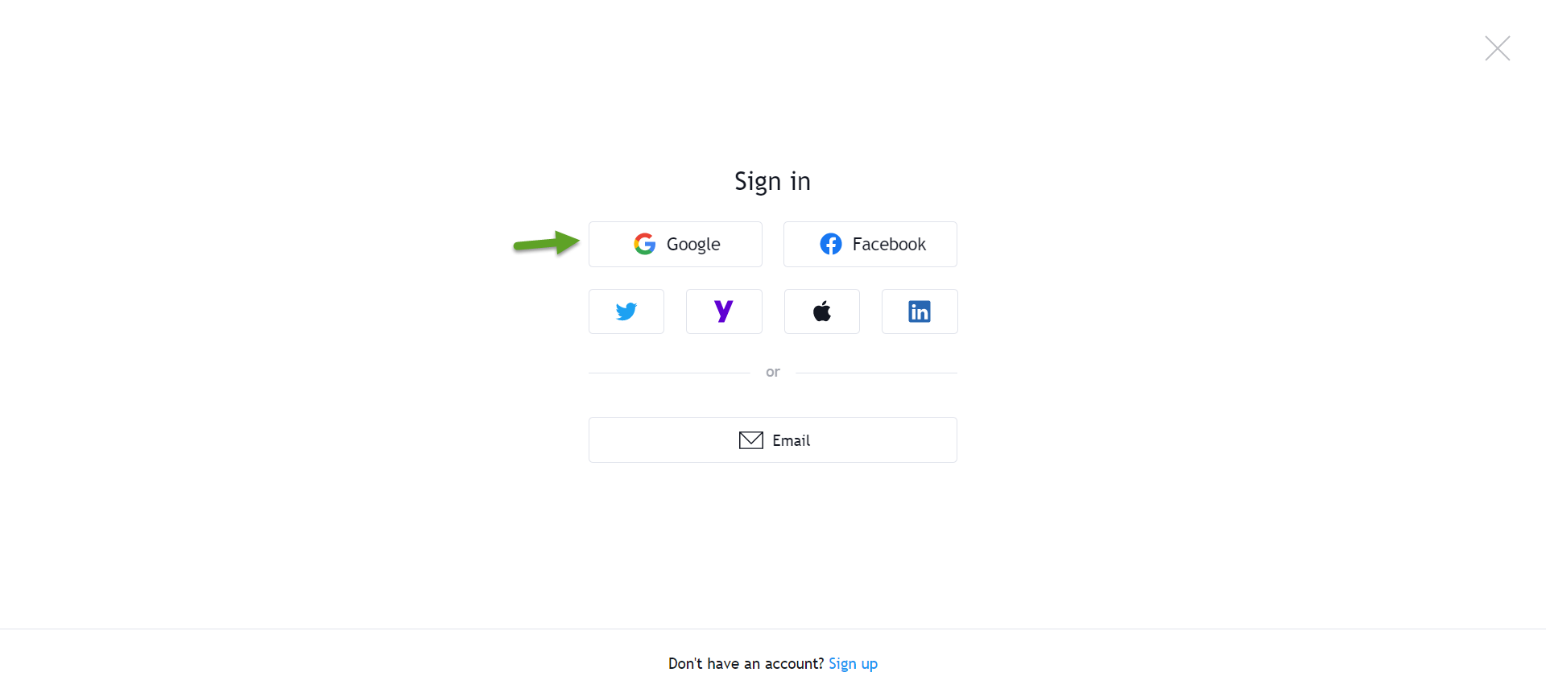

Type: [tradingviewtest604@gmail.com](mailto:tradingviewtest604@gmail.com) and password Tv604!@#

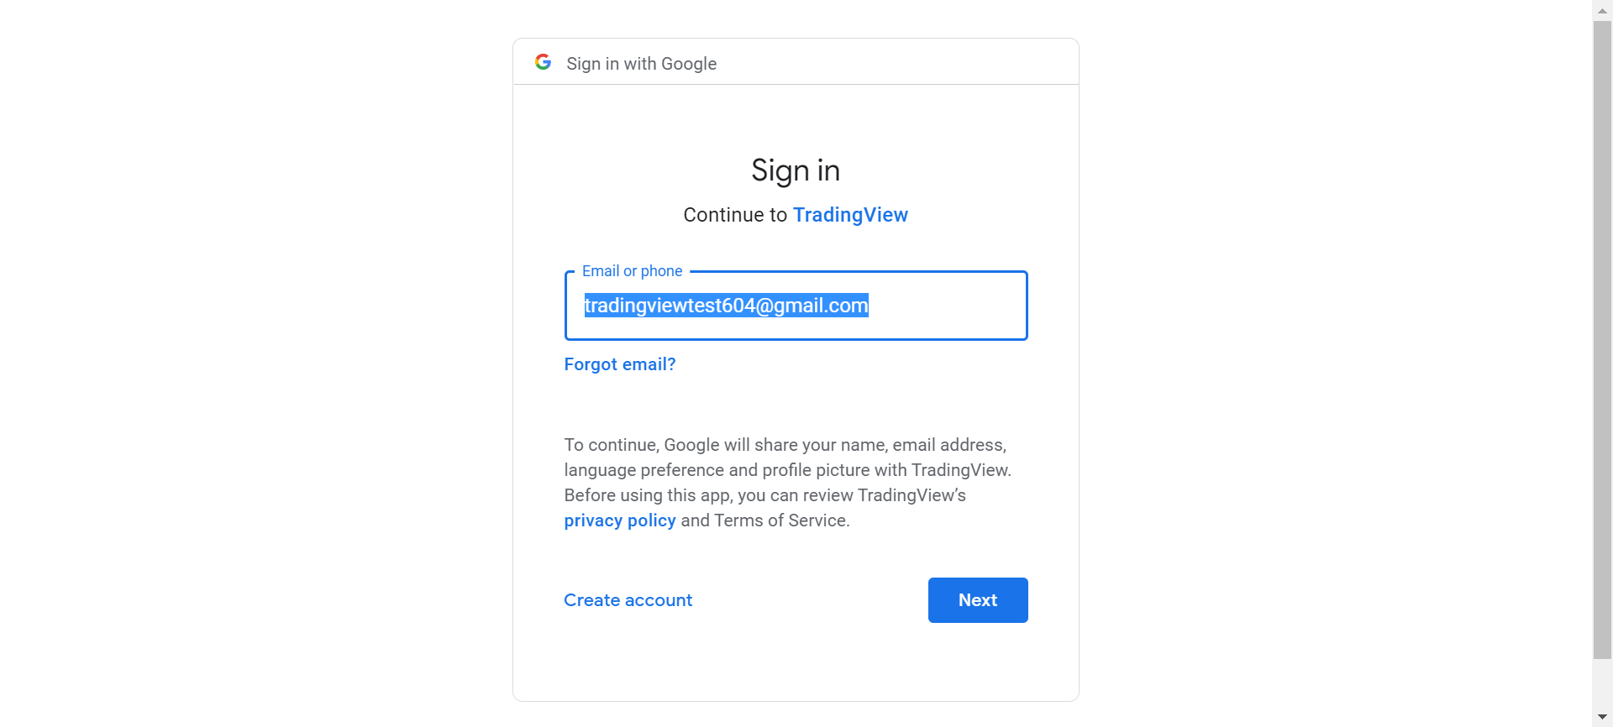

Click on “Chart”

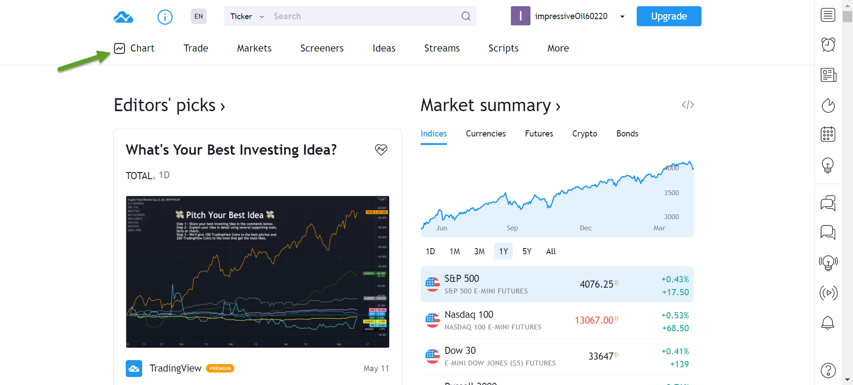

I have setup chart + signal indicator. This is S&P EMINI which is open basically 24 hours 5 days week.